PRINCIPLES OF DATABASE SYSTEMS

PROJECT REPORT

NEW YORK UNIVERSITY

TANDON SCHOOL OF

ENGINEERING

DEPARTMENT OF COMPUTER SCIENCE

**Submitted By:**

Aman Kumar Mahato (N-12198142)

**Project Description:**

Users will be people who enjoy outdoor activities such as hiking, bird-watching, fishing, snowshoeing, kayaking etc, and want to socialize with other users with similar interest, to share information about the places they visited such as tips on popular fishing spots, location of stunning views, information about new trails or new parks, etc.

**Introduction: goNYU**

goNYU is a free web application and social networking website for Outdoor Enthusiasts, particularly focused for NYU Students. This web application is very similar to Facebook or Timeout where people of similar interest can interact with each other and can plan their trips together. This could be a best platform for students at NYU who are looking for someone with similar interest and wants to hangout together or share some of their experience regarding any trips. They can also share their pictures and put description in it to make it more expressive. At this point of time, it has very limited features like making friends, commenting on other pictures, looking into other interests, checking other registered user’s profile, searching for any particular location. In days to come, I would like to integrate messaging system within this application which will make the registered users to communicate with each other via this app.

For the implementation of the afore mentioned, the schema designed in the first part was redesigned and slight change was made in the implementation as well where the users instead of putting the independent descriptions, now will be speaking through the images and photo caption. The idea is to make the app very similar to pinterest.com. (Reference: <https://www.pinterest.com)>

**Revised E-R Diagram**

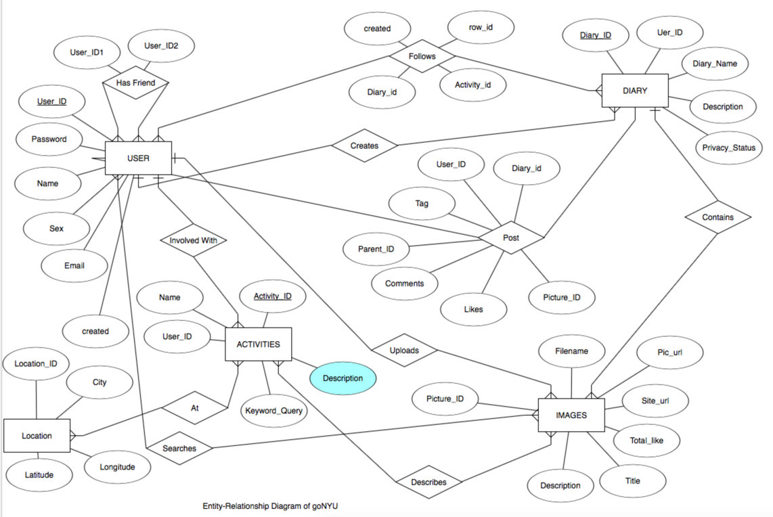

**How It Works? (User Manual)**

The way this web app works is, first we need to make a user account. For that we have to sign up. This stores the user information and creates a profile for him/her. The sign up page of this app is:

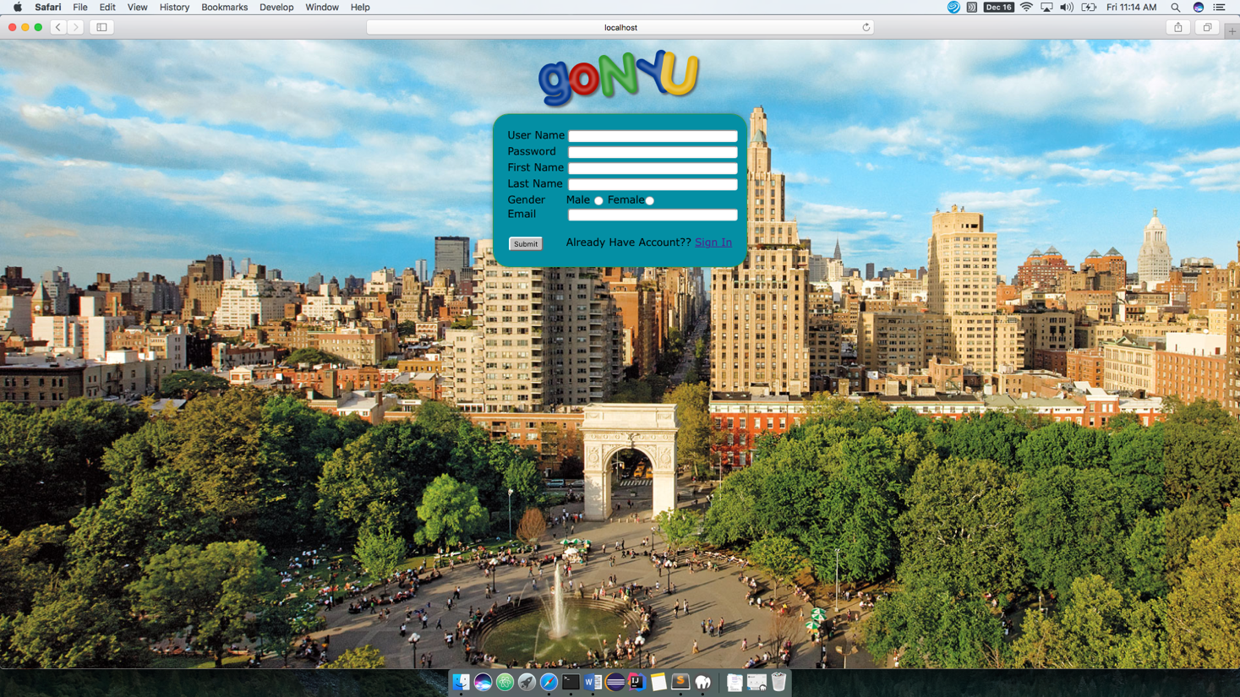

In sign up page, potential user has to fill all the necessary fields which includes user name, password, first name, last name, gender and email. If user has already signed up but if h/she some how ends up at this page, there is option to go to login page as well which has a hyperlink to login page. Once the user signs up for the new account, it directs to the login page as shown below:

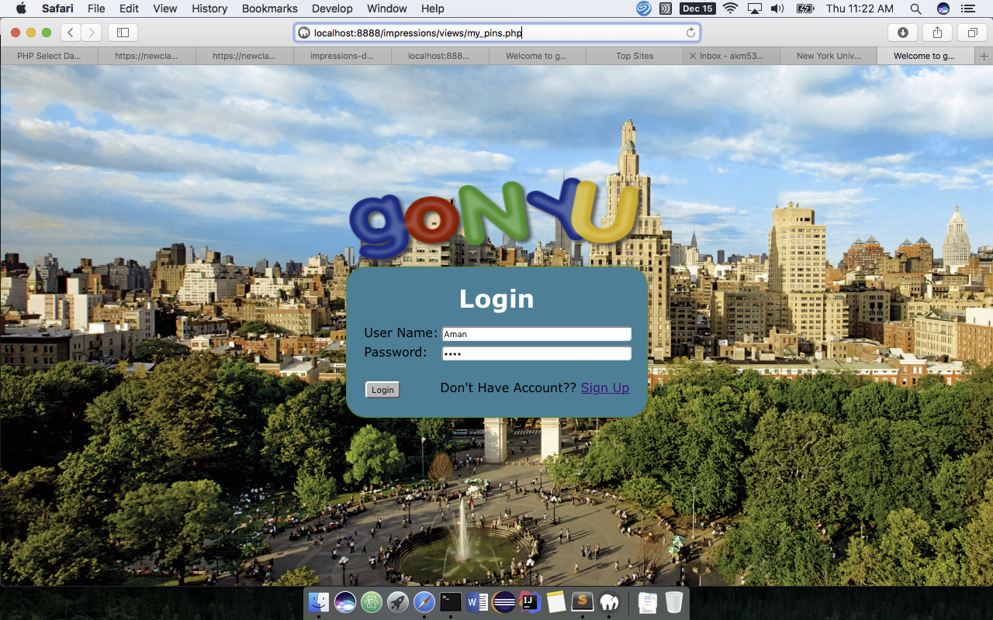

Here, the user has to enter the user name and the password. These credentials are then tallied with the one stored in the database for the security and validation purpose. If they are a match, the user is allowed to log in and they are directed to the landing page where user can see all the posts he/she has made in the past. If h/she is a new user, the landing page will be empty for the first time until a new activity/pictures are uploaded.

This is very similar to the Facebook feedback with only difference being, here the feed is local ie. all the activities and images shown in landing page belongs to the user’s own account and not from the other user’s account. To view other’s diary, one must be first his/her friend and the diary one wish to view must have the access right set to Friends or Public. Private contents won’t be shown to other users even if they are a friends. The landing page of this web app looks some thing like the one shown in the screen shot below. In the screen shot, we can see an image which has a description, tags and likes. It is basically contained in a dairy (Board, explained later in the report) where description tells about the image as fed by the owned of the image. In short, each diary can be thought of as an event and each image can be thought of an activity in which user/owner is interested in. Tags field is used to tag the people as in other famous social networking site like Facebook. It also has an option to like, as seen in the top left corner. Any other user who view this diary or an activity can like this. The total number of like is counted and shown at the bottom. If owner wants to remove this post from his diary, h/she simply needs to click on the circle at top right corner of the activity.

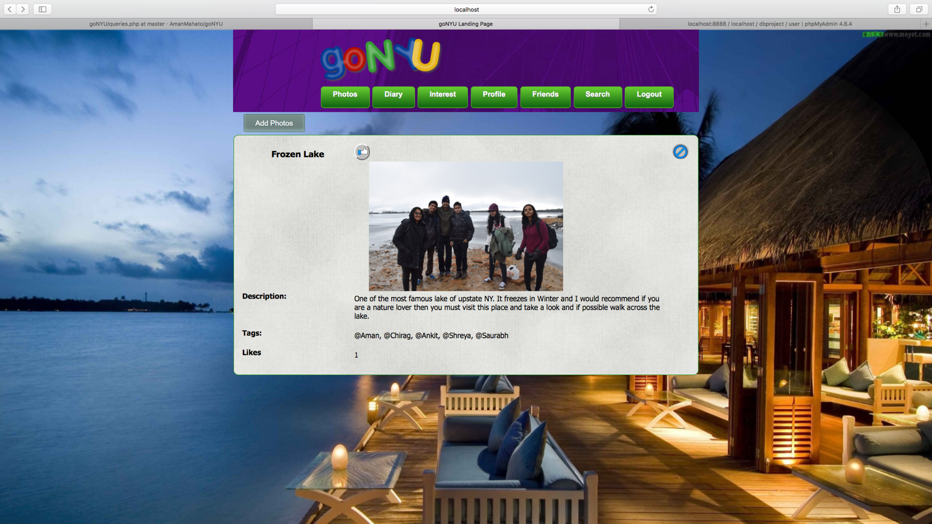

Now to post some thing, like the picture or activity, first the user has to create a new Diary. This diary can be thought of as a collection or an album which is used to organize all the events or activities of one type at one place. So to create a new activity, user have to first click on the Diary tab at the top and has to provide the Diary name and then it also asks for the small description which describes what exactly the diary is about. It has a privacy setting as well which controls the behavior of who can view this diary. There are three options in the privacy setting viz, Friends, public and Private meaning, if the setting is set to friends, then only friend can view it, if its public then anyone can view it who has signed up for this app and if its set to private then no one can view it except the owner.

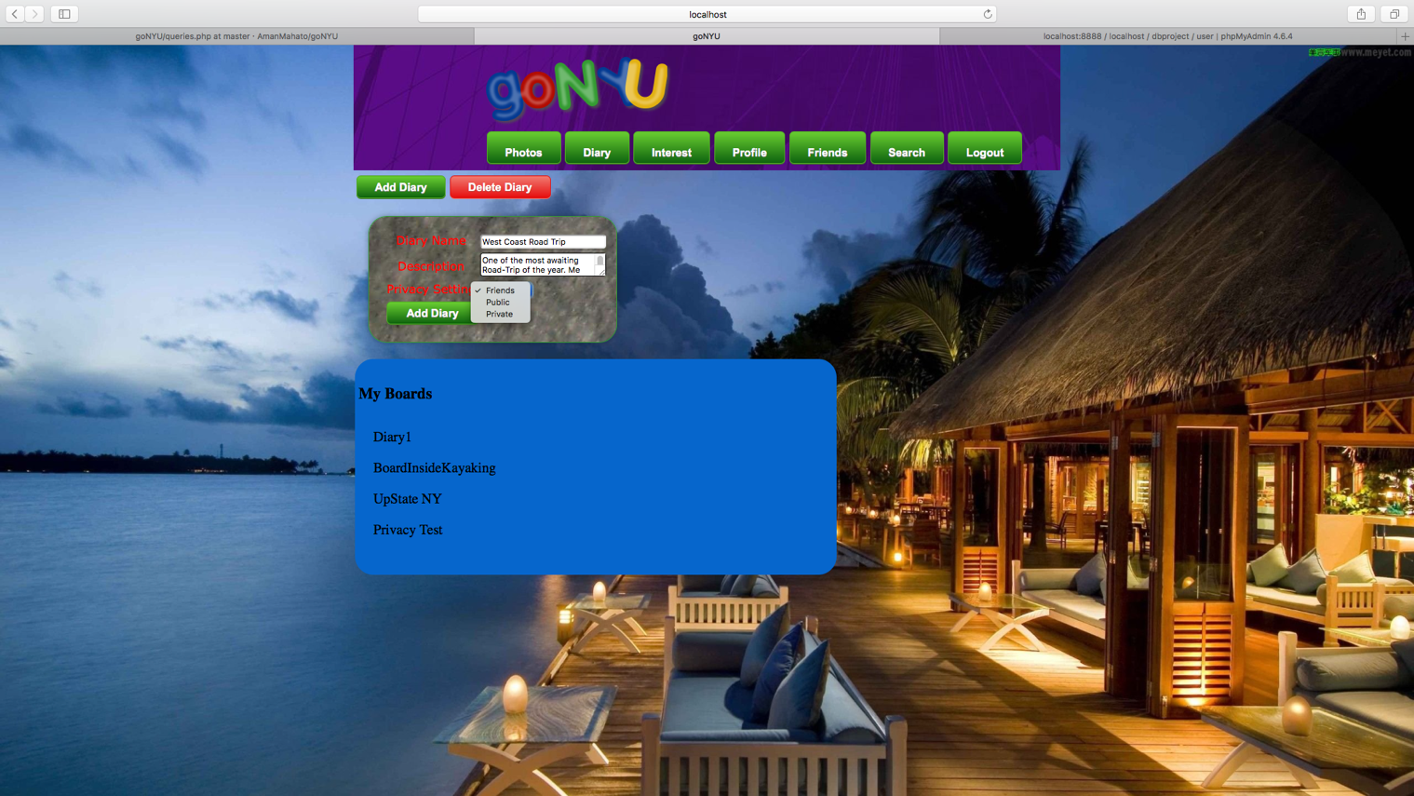

Once the form is submitted, it will create an empty diary. This can be verified by the name saying “West Coast Road Trip” in the My Diary List. To see the description of any diary, one needs to put the mouse pointer above it and it will show the description.

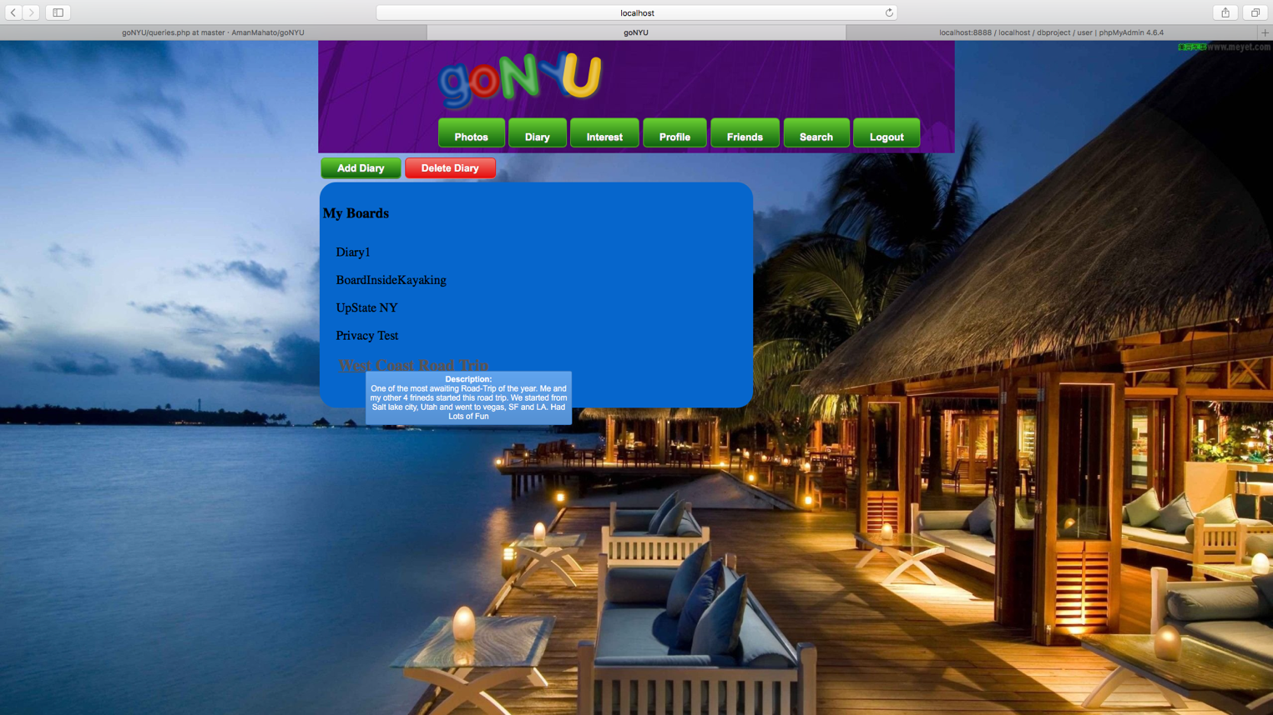

Once the Diary is created, to add the activities/images, one has to click on the Add Photos which will open a form with the option to either upload the image or take it from the web. It will also have a field where one can put the description of how the place was or anything they want.

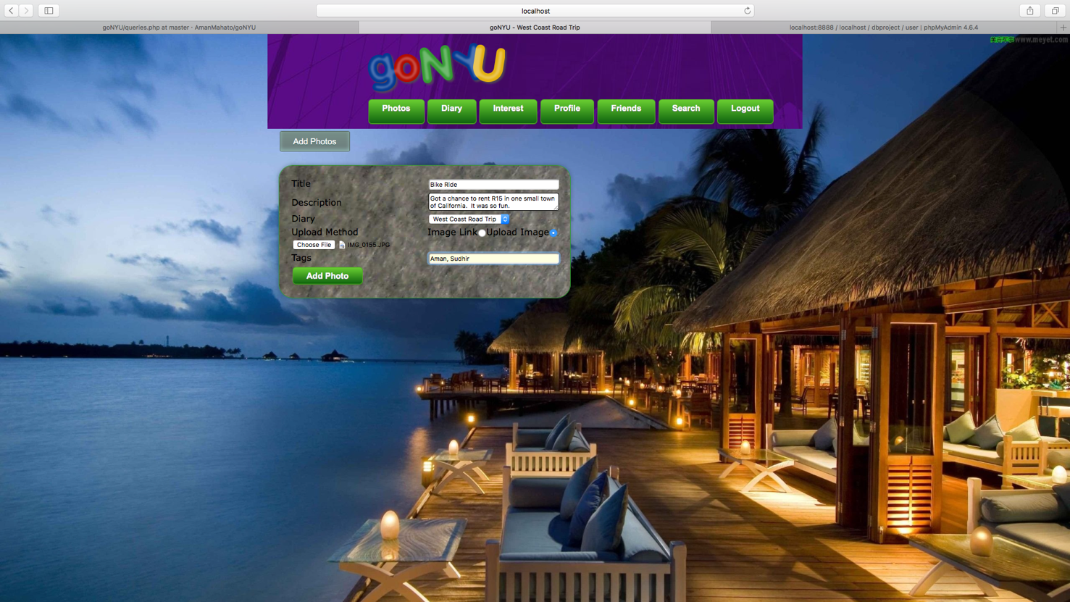

Once, the activities are added to the diary, it will be shown to the landing page as the news feed as shown below:

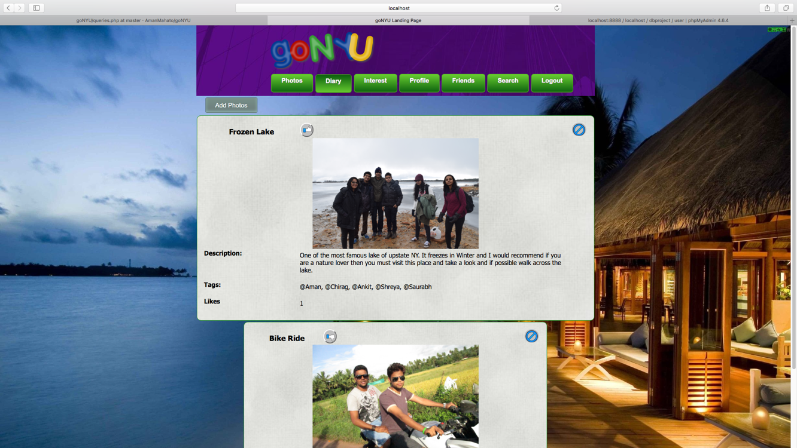

One can also add activities or images without entering into any Diary. In that case, there will be a separate field where one has to select a Diary from the drop down menu. The image/activity will be associated with the selected Diary as shown below.

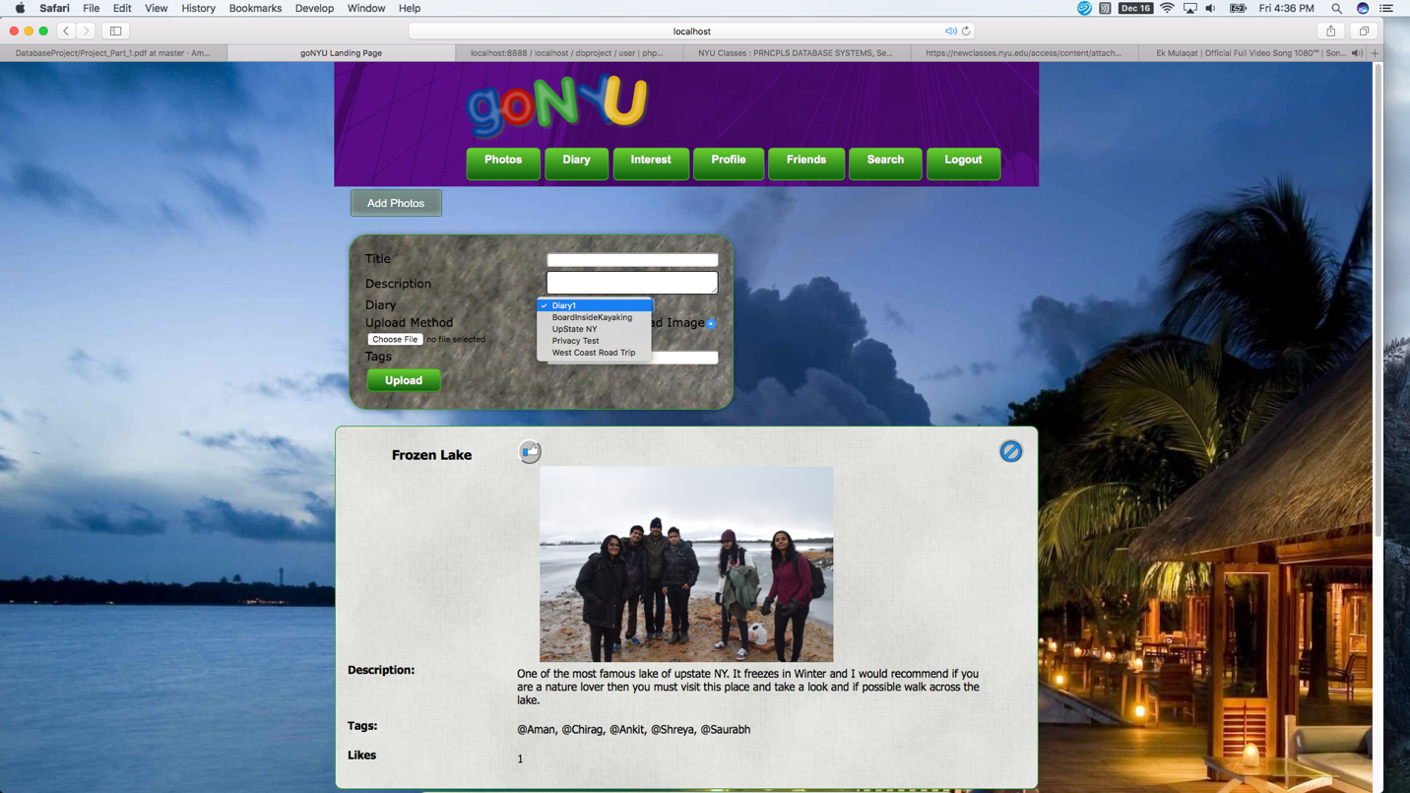

To Post a comment on any particular activity, one has to click on the image which will take to the another page with the comment option as shown.

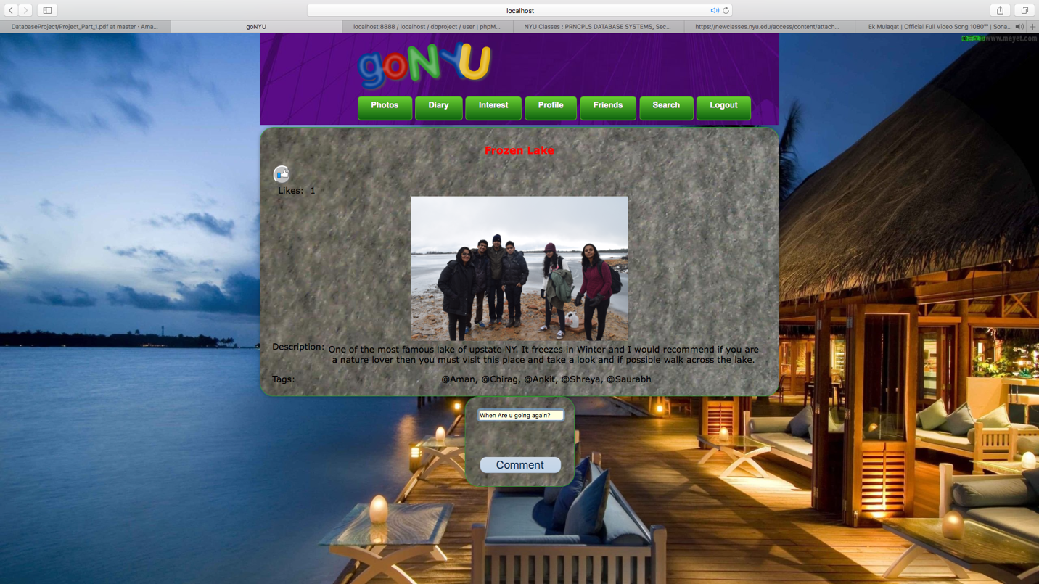

To view all the diaries of other users irrespective of the fact that they are friends or not, one has to go to Diary and then to Search Diary. It will list all the Diaries present in the database. Now to know the description of the diary, place the mouse over the Diary name or to check the associated activities, simply click on it which will take inside the Diary.

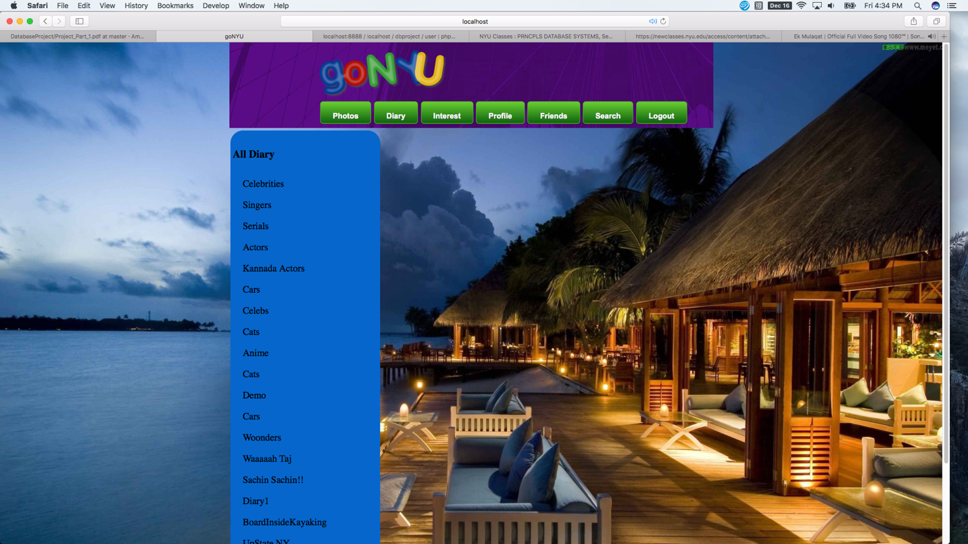

To store the activities or interest, one has to first go to the interest tab which will take them to the interest page where all the interest will be displayed. Now to add the interest, click on the Add Interest button or to delete the interest click on the Delete interest button.

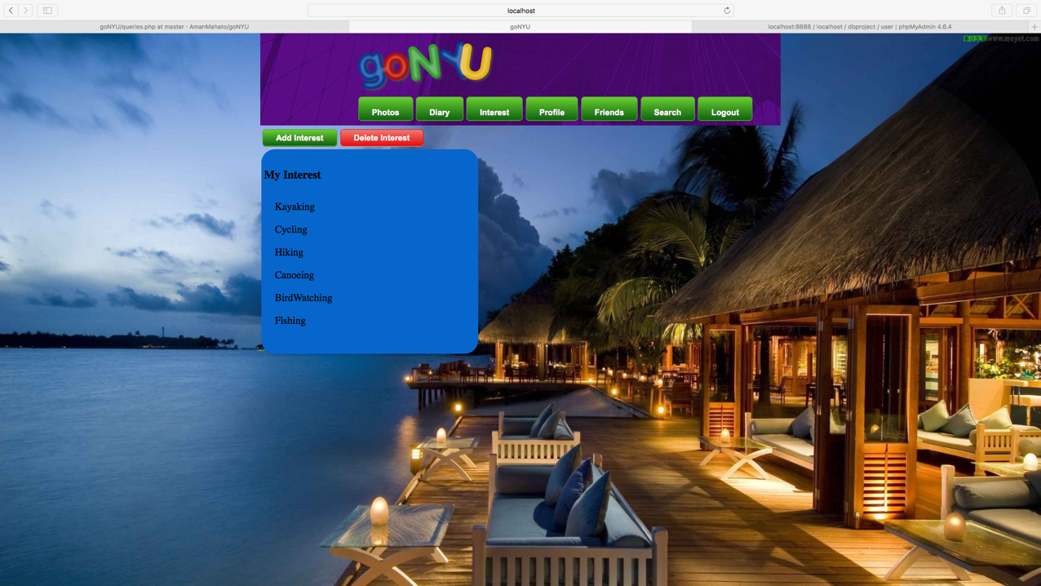

To view the profile, go to the profile page by clicking on the profile tab. Here, the user’s information, notifications of friend request are displayed along with the option to edit the profile by clicking on the Edit Profile tab as shown below.

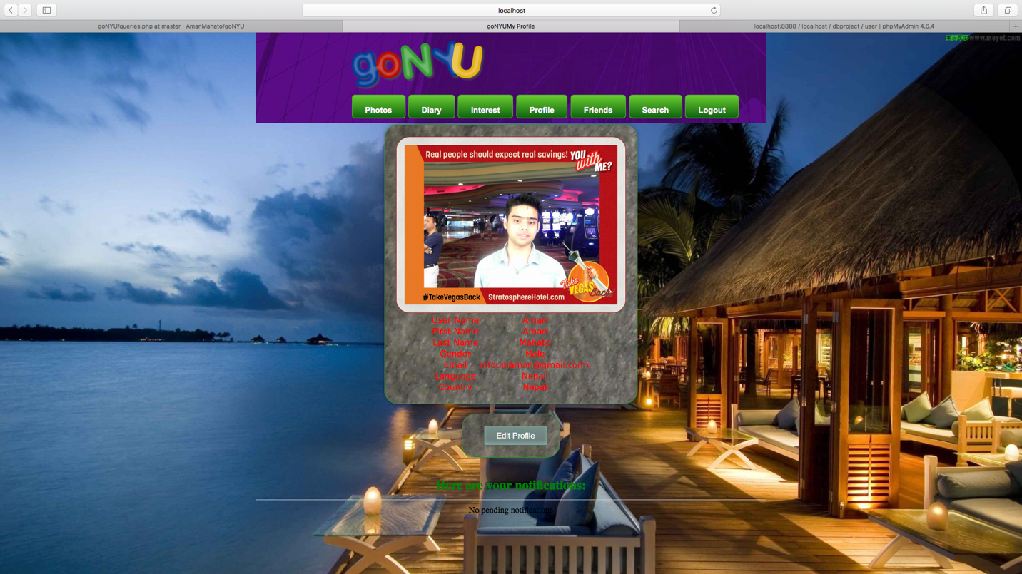

If one goes to the Edit Profile tab, it will direct to the new page where he/she can change the profile picture, password, gender, country, language etc, the only thing which cannot be changed is username. It is made read-only for the purpose of uniqueness. In the screen shot below, the email address was changed to new one. The new email is depicted in the screen shot below.

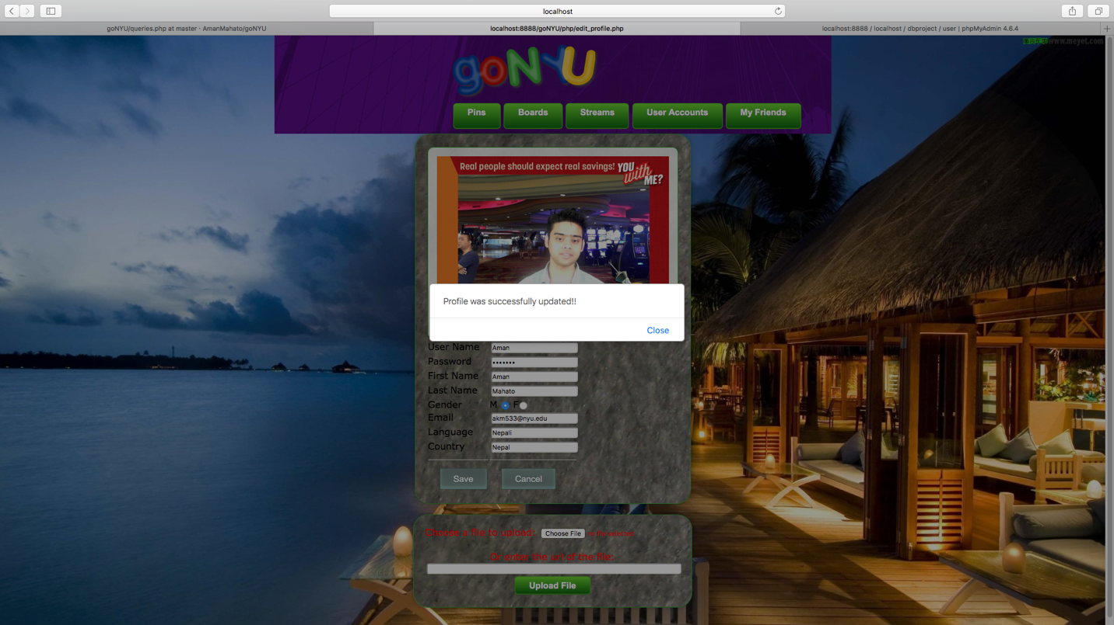

To list all the friends who ever are in the friend list, one has to click on the Friends tab as shown below;

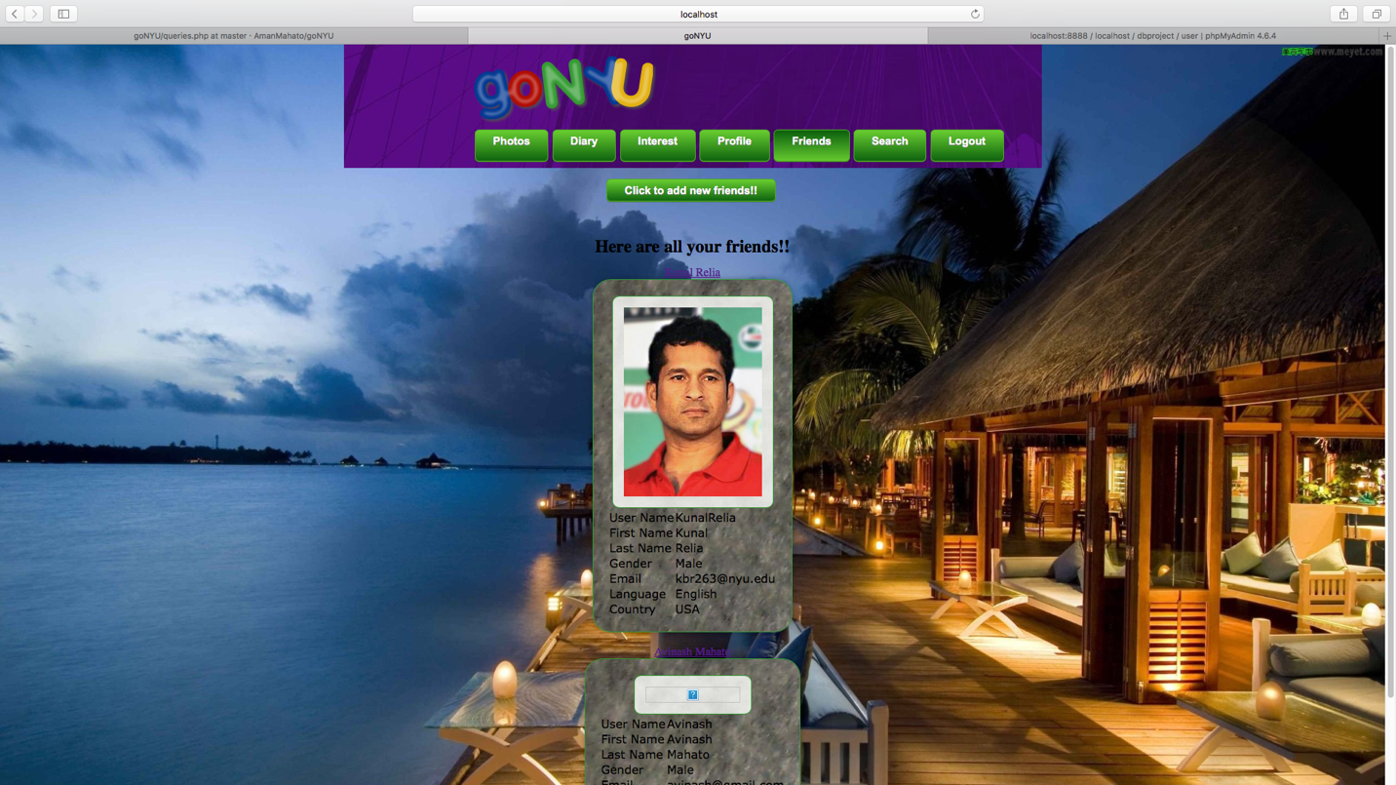

Now to send a friend request, there is an option which says “Click To Add New Friend”, it opens a new form where user can send a friend request by typing the user id of another person and sending him/her the friend request.

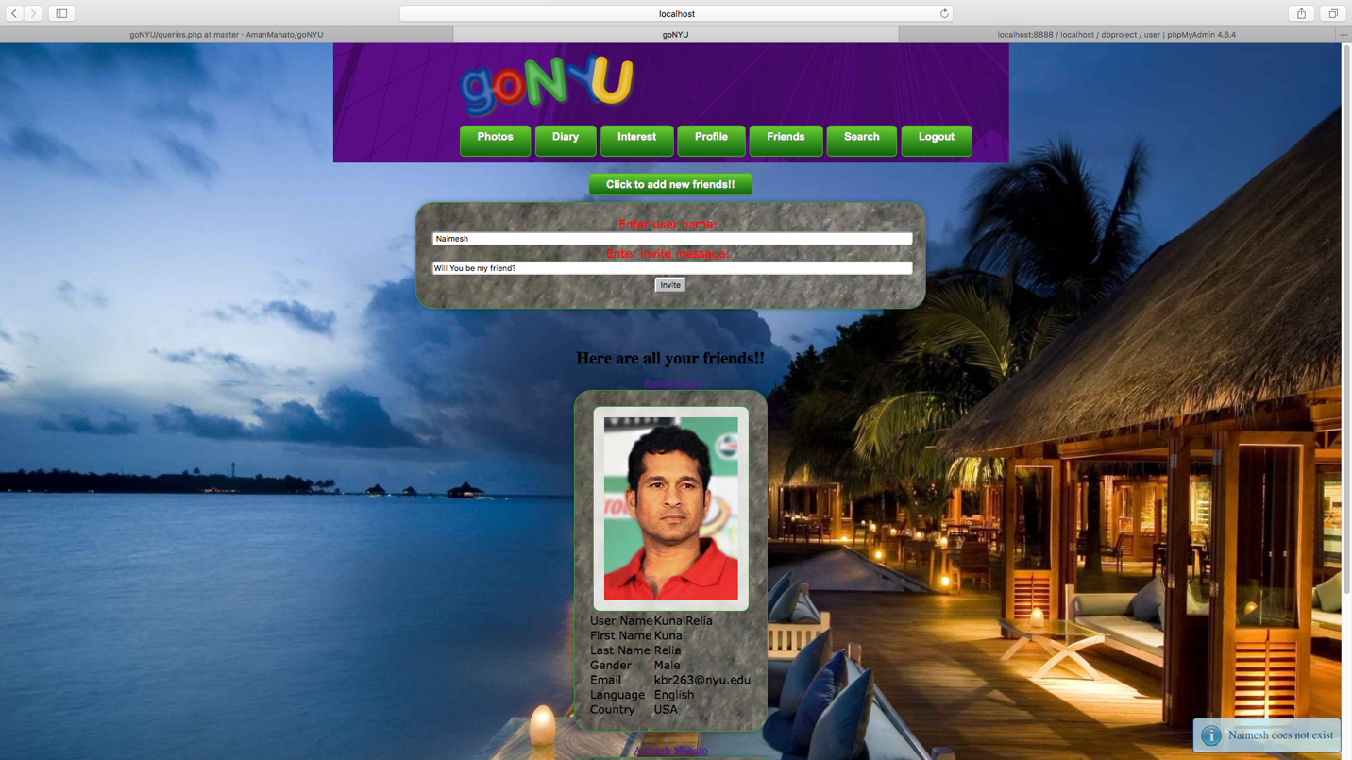

At Receiver end, when a friend request is received, it is notified in the user’s profile and the receiver have the option to either accept it or reject it as shown below.

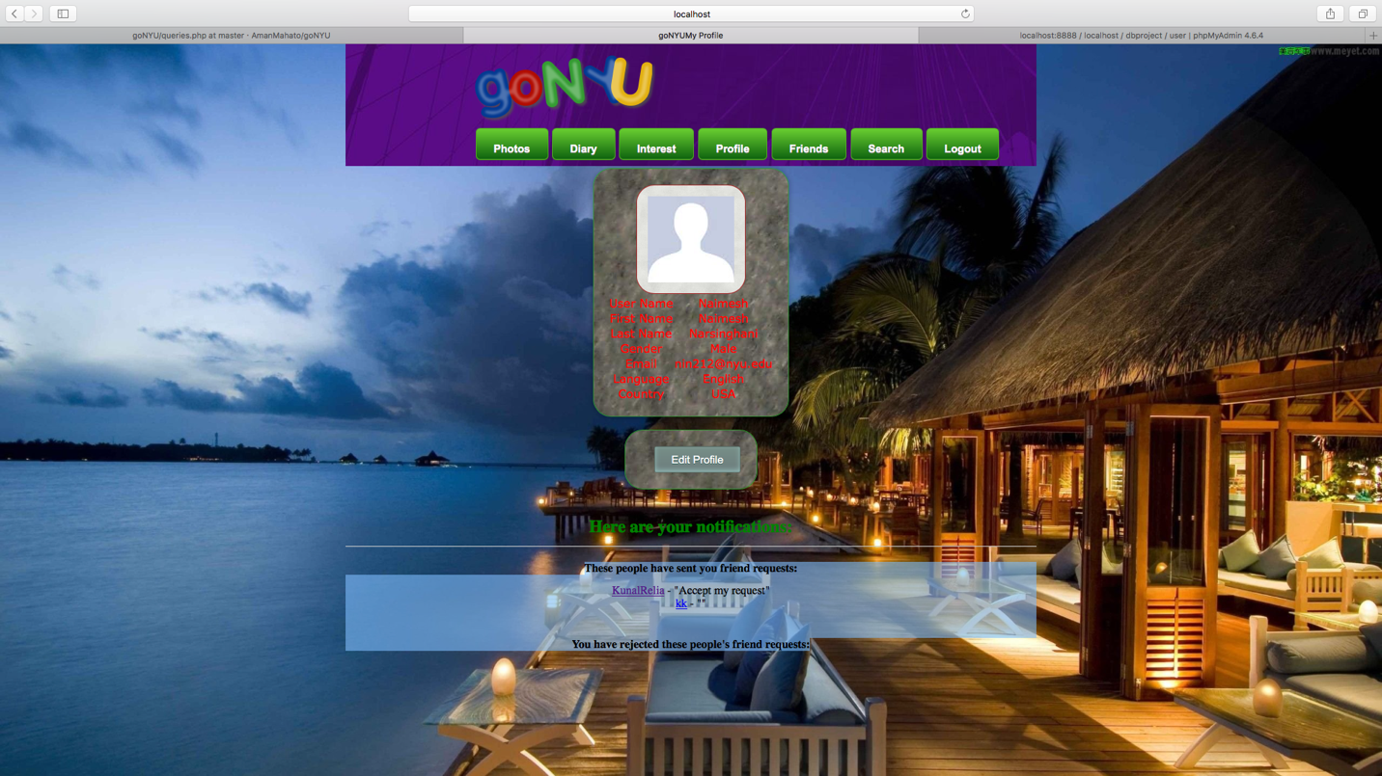

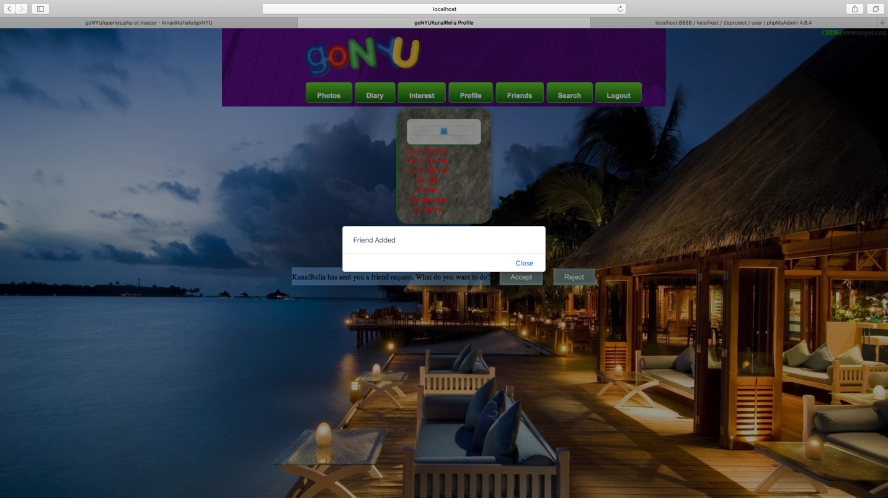

Once the friend request is accepted, the Friends page of both the sender and receiver gets updated as shown by screen shots below:

**At Receiver’s End:**

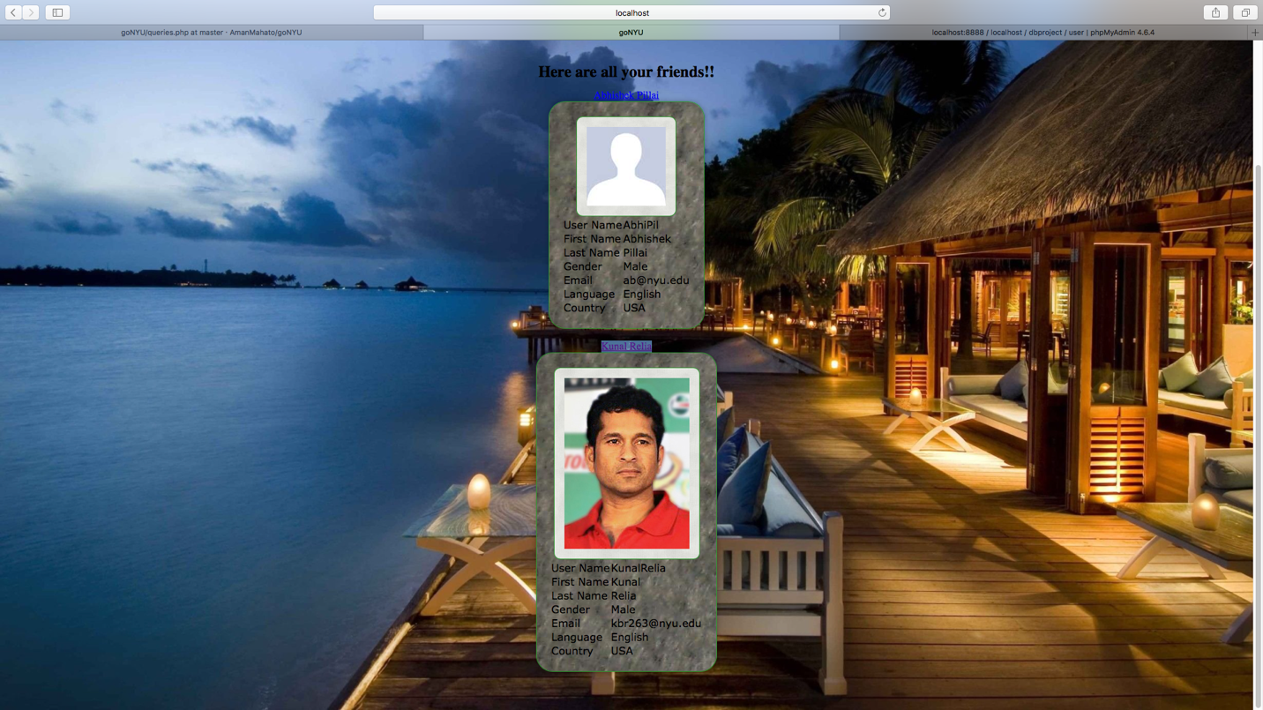

**At Sender End:**

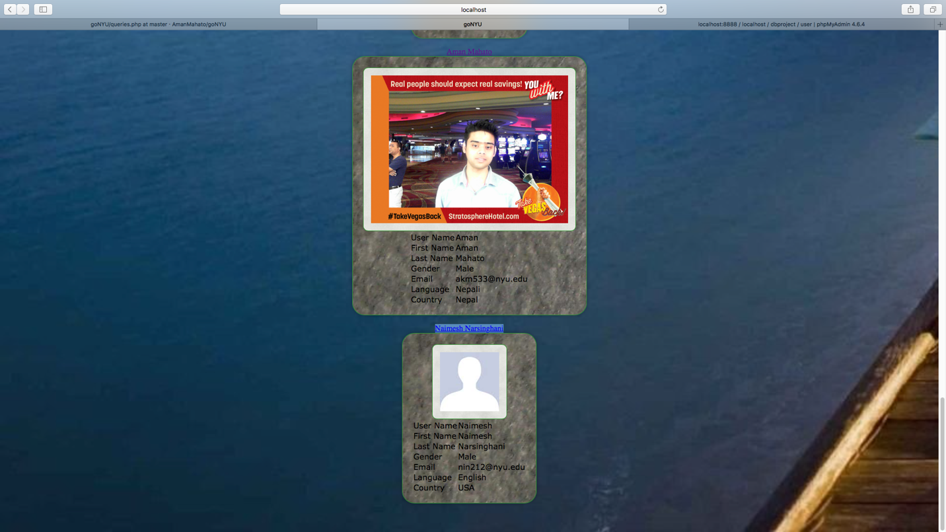

Search Tab is used to either to search for Other’s diaries or users who are not a friends. To search for diaries, one should start a search with # where as to search for person, one should start the search with @ as shown in the screen shots below:

**Search for a person:**

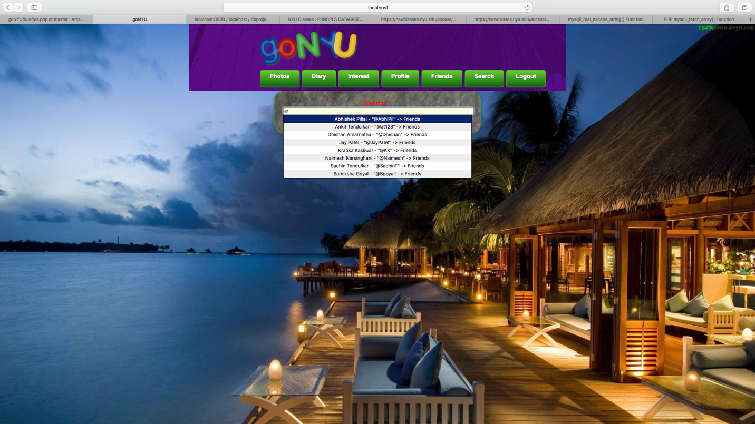

**Search for a Diary:**

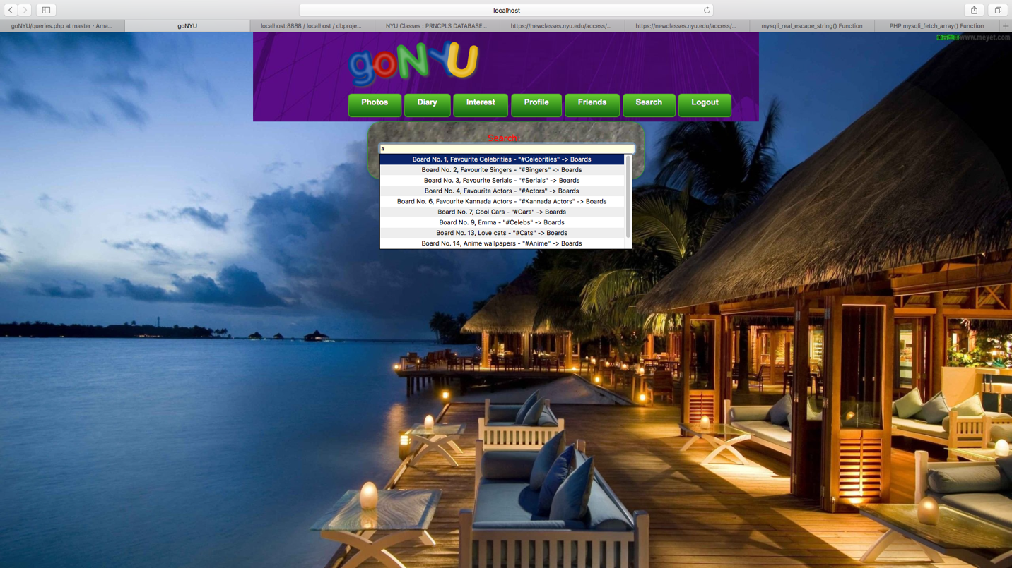

**Additional Features:**

Some of the additional features of this website are:

1. Users can comment on other user diary.
2. Error messages:
   1. If a potential user tries to make an account with an existing user name, it will generate an error message.
   2. If user name or password is wrong, it generates type mismatch message.
   3. Checks for friendship. If two users are already friends, sending friend request won’t be allowed.
3. Images can be uploaded using URL along with the normal file upload.
4. Auto completion when searching for a diary or looking for some other user who is not in friend list.

**Conclusion:**

This project has enabled us to understand the concepts of the database in a better way and implementing it on a real time working application has made it better for us to understand the basic difference between theoretical knowledge and practical implementation. It allowed us to solve some of the most trivial implementation issues, that are certainly going to help in other feature endeavors as well. The most challenging part of designing the certain database and normalizing it helped us understand the cost specific metrics of implementations and hence broadened our spectrum of thinking. It was a challenging but a very interesting experience to work on this project.

**Reference:**

1. [www.github.com](http://www.github.com)
2. [www.stackoverflow.com](http://www.stackoverflow.com)
3. <http://www.w3schools.com>
4. <http://php.net/manual/en/index.php>
5. [www.youtube.com](http://www.youtube.com)
6. professor lecture and slides
7. Ref: https://www.pinterest.com